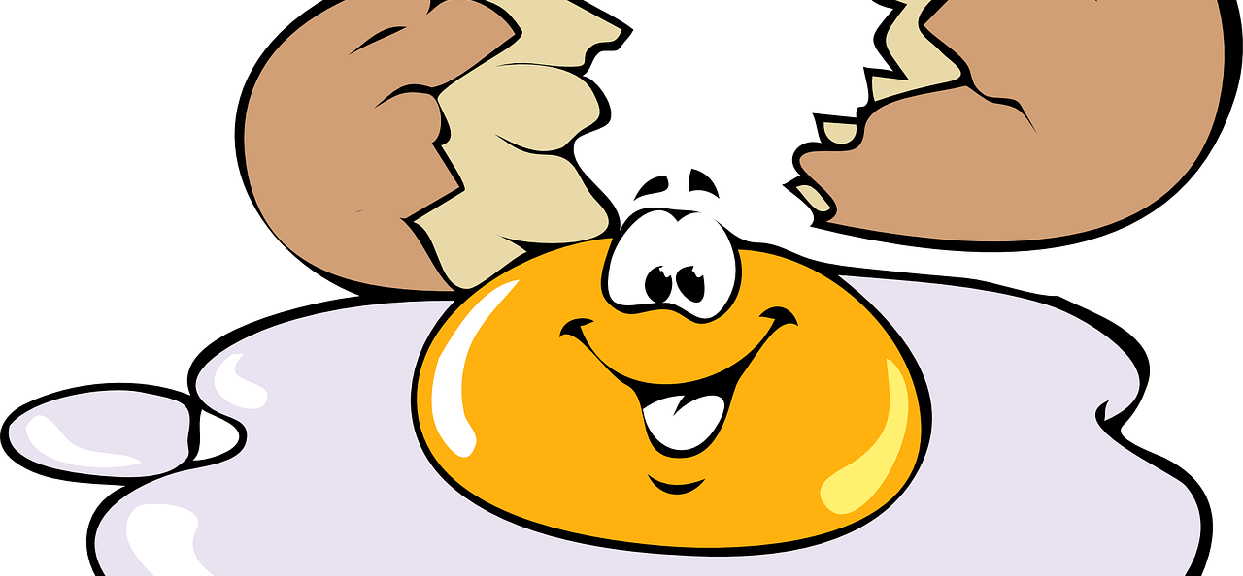
Dúshlán na hUibhe ag Titim Anuas

Dear córas chun ubh a chosaint ar bhriseadh nó scoilteadh tar éis di titim anuas ó airde. Chun do dhearadh a thástáil, ligfear don ubh titim anuas ar dhromchla crua ó airde 6 troithe.

Ábhair: Bain úsáid as aon ábhar a bheadh ina chuidiú, dar leat, chun an ubh a chosaint agus í ag bualadh an dromchla.

Sa bhosca thíos, tarraing léaráid de do dhearadh agus cuir nótaí léi.

Cén fáth, dar leat, a n-éireoidh le do dhearadh an ubh a chosaint ar bhriseadh?
__________________________________________________________________________________________________________________________________________________________________________________________________________________________________________________________________________________________________________________________________________________________________________________________________________________________________________________________________________________________________________________________________________________________________________________________________________________________________________________________________________________________________________________________________________________________________________________________________________________________________________________________________________________________________________________________________________________________________________________________________________________________________________________________________________________________________________________________________

Torthaí:
Ar tháinig d'ubh slán ón titim anuas?

Tháinig/Níor tháinig

An raibh na hábhair a d'úsáid tú oiriúnach? Cén fáth a raibh/nach raibh siad oiriúnach?
________________________________________________________________________________________________________________________________________________________________________________________________________________________________________________________________________________________________________________________________________________________________________________________________________________________________________________________________________________________________________________________________________________________________________________________________________________________________________________________________________________________________________________________________________________________________________________________________________________________________________________________________________________________________________
An ndéanfá aon rud ar bhealach eile?
_________________________________________________________________________________________________________________________________________________________________________________________________________________________________________________________________________________________________________________________________________________________________________________________________________________________________________________________________________________________________________________

